Name: Priyanka

Mail id: [priyankabaskar7797@gmail.com](mailto:priyankabaskar7797@gmail.com)

Task: Create a shell script to print the HTTP error code of guvi.in & print, the success/failure message based on the error code response 2. Given a file, replace all occurrence of the word ""guvi"" with ""learning"" from 5th line till end in only those lines that contains word ""welcome""

1. Print the HTTP error code of guvi.in

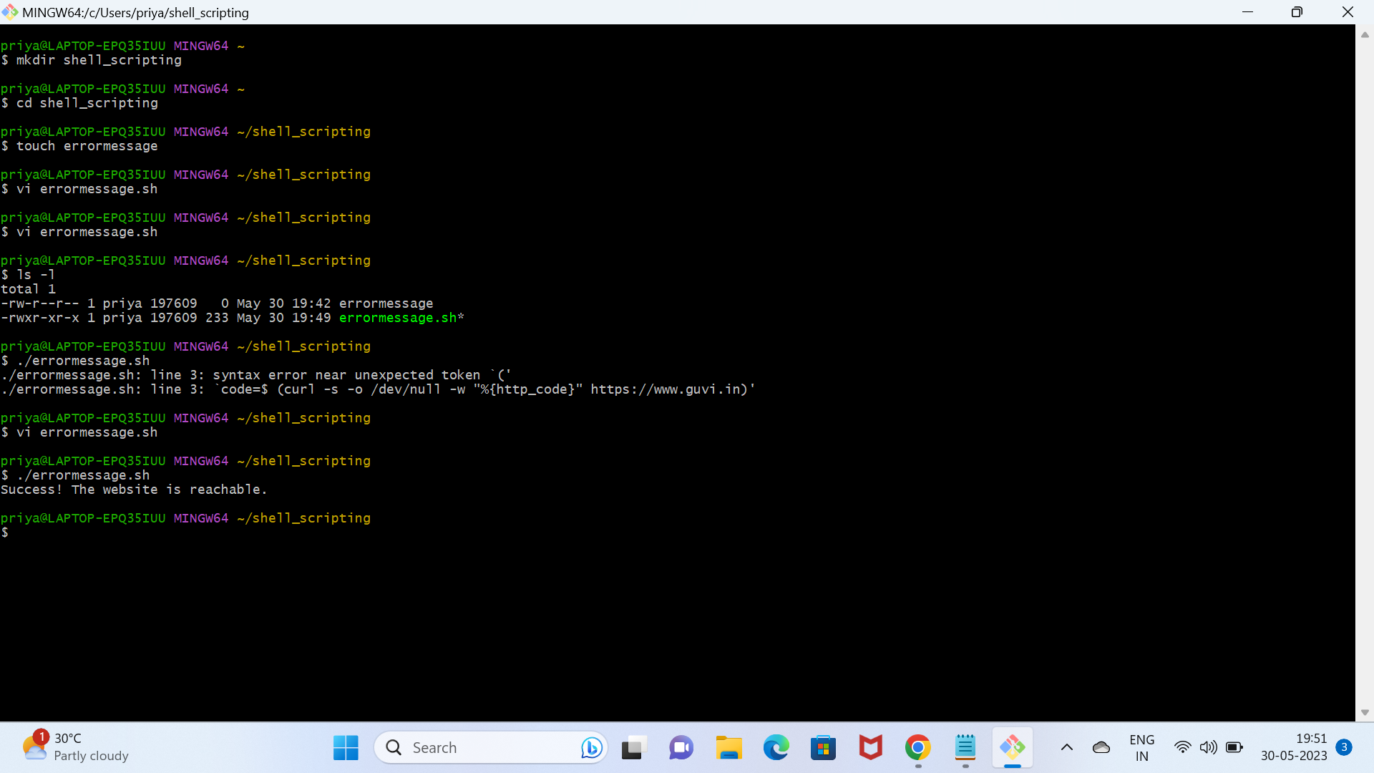

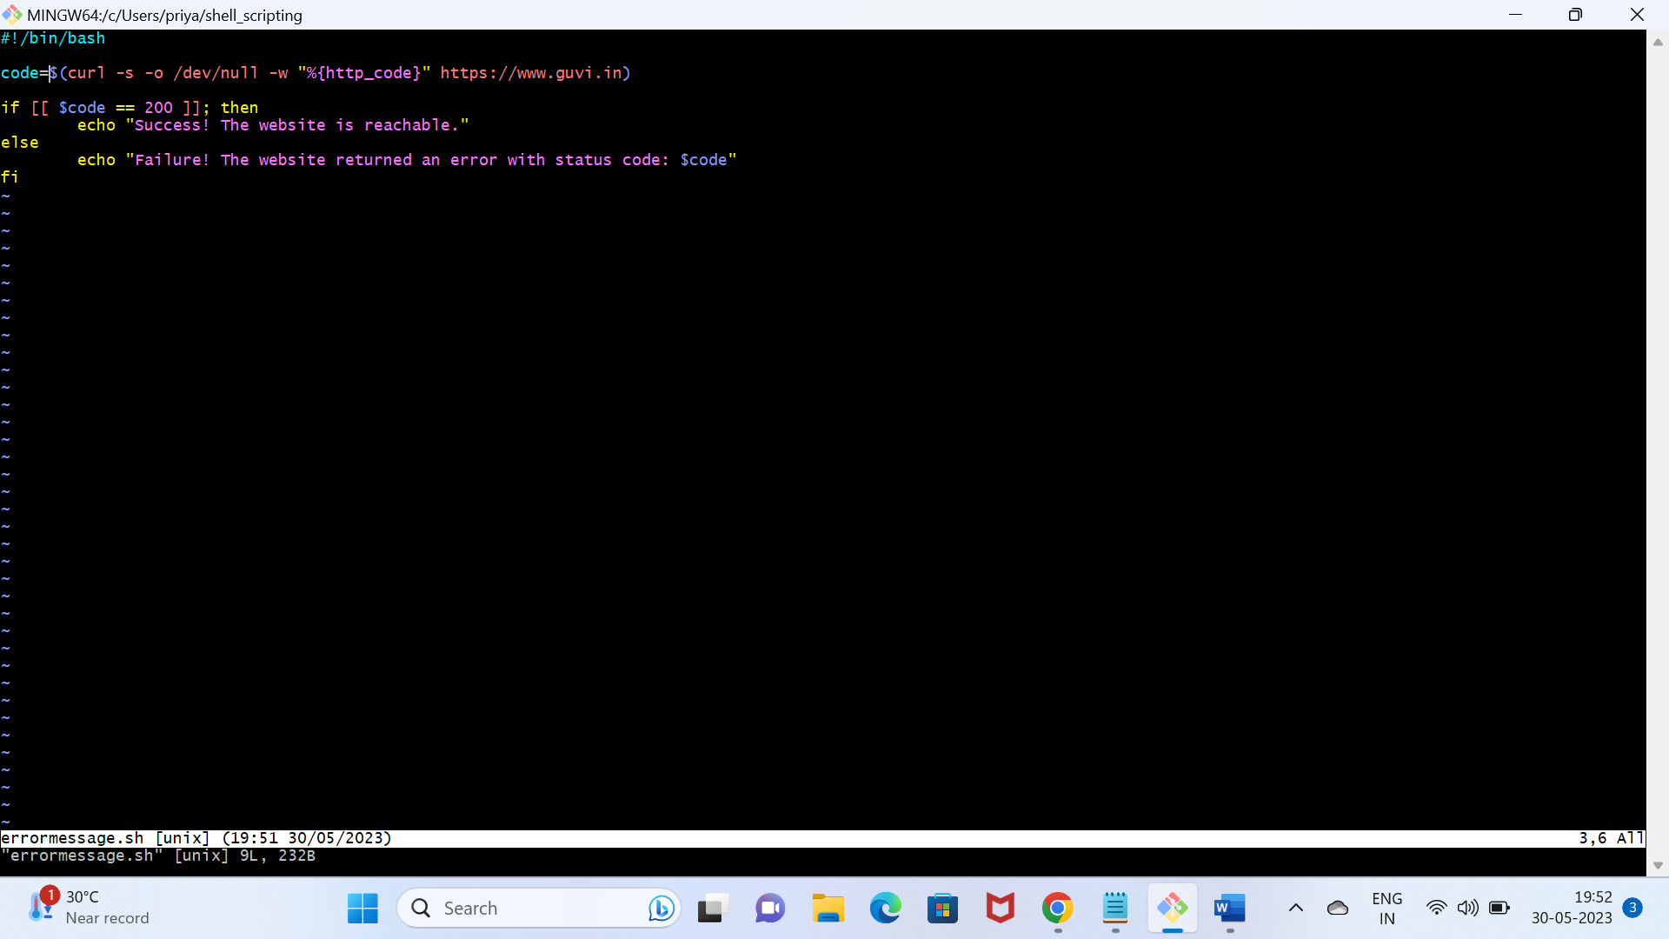

1. Replace all occurrence of the word ""guvi"" with ""learning"" from 5th line till end in only those lines that contains word ""welcome""

